Name: IBRAHIM ALSHAYEA | ID: 202176470 | Section: 53 | Date: 1/25/2024
Brief explanation:
First of all I started to define the data fields. Then, I wrote the needed methods such as getter, setter, and toString methods. After I finished structuring all the classes. I wrote a test class to test the classes.
Task 1 Output:
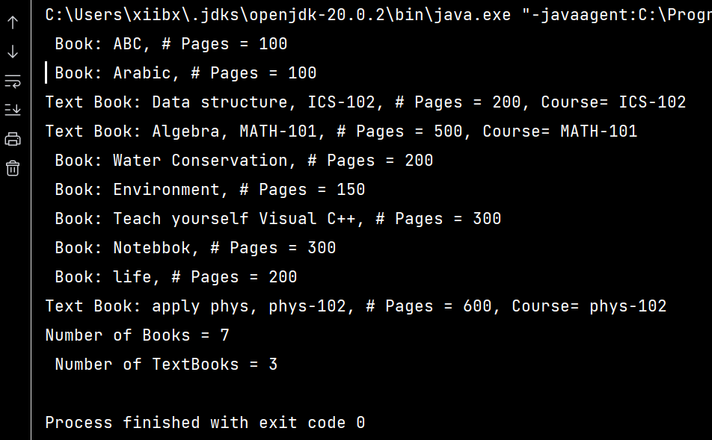

Part of the code :
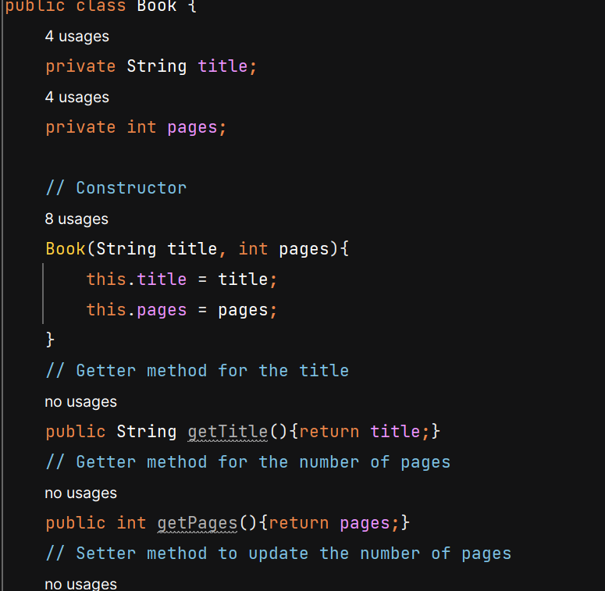

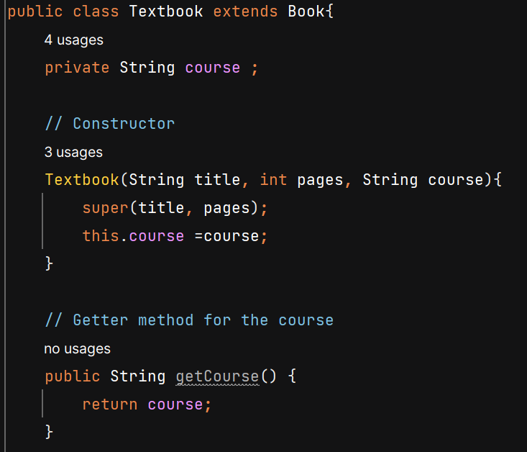

Task 2
Output 1:

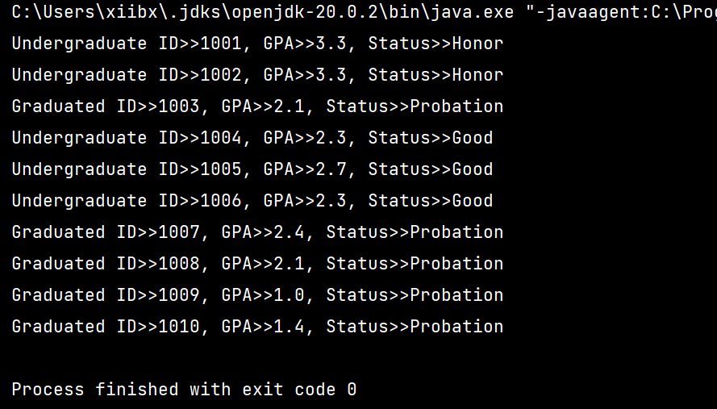
Output 2:
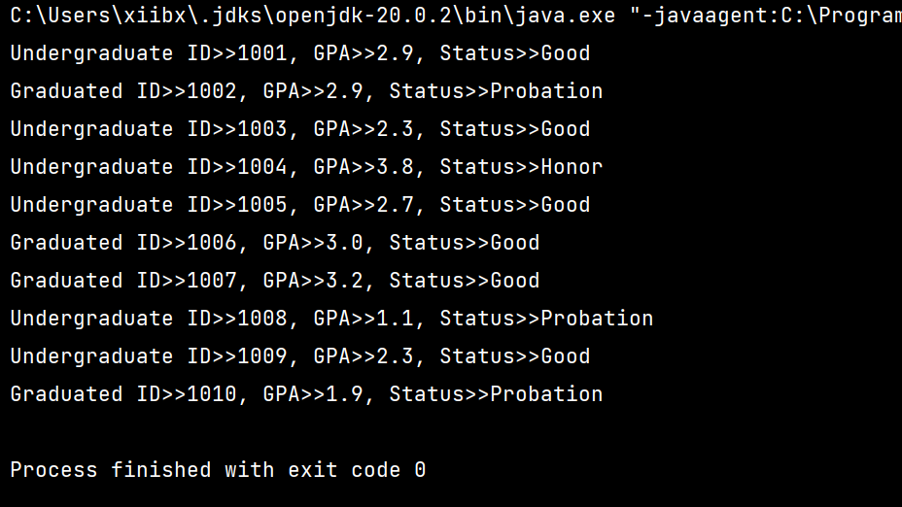

Part of the code:
